USER MANUAL – PATIENT USPARK

LOGIN AND SETUP ACCOUNT:   
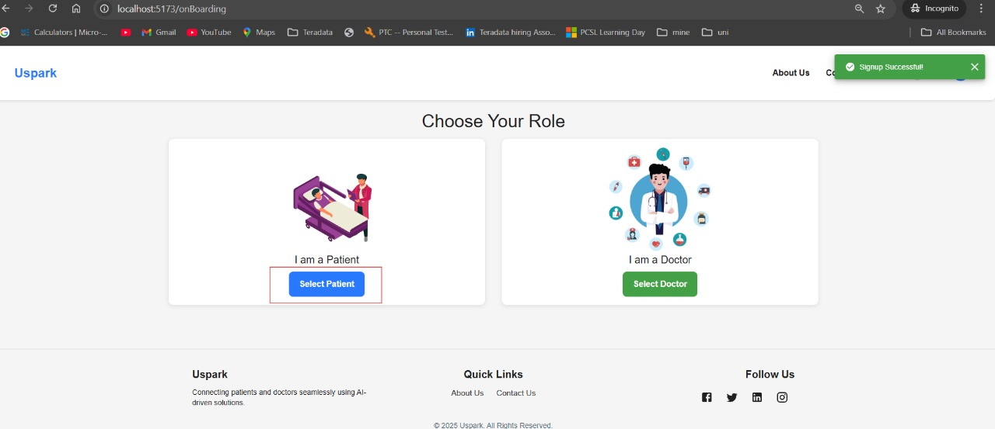

Once all the login details have been entered, you are directed to onboarding page where Select Patient is to be selected to create a patient profile.

ONBOARDING:

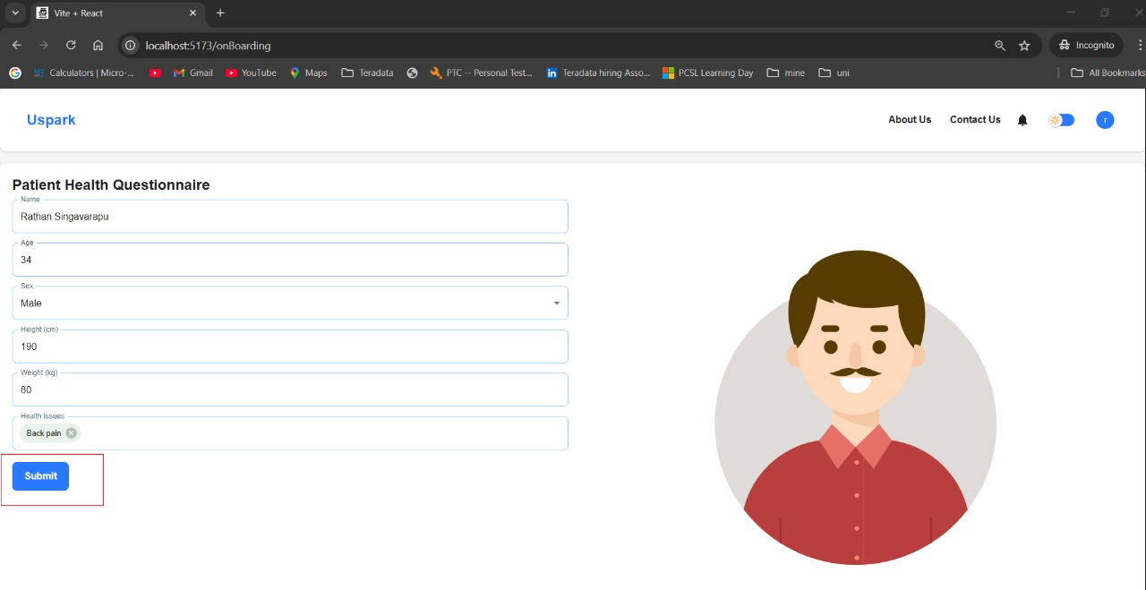

All the details for onboarding are to be filled and click on submit to onboard yourself as patient.

TAKING INITIAL ASSESMENT:

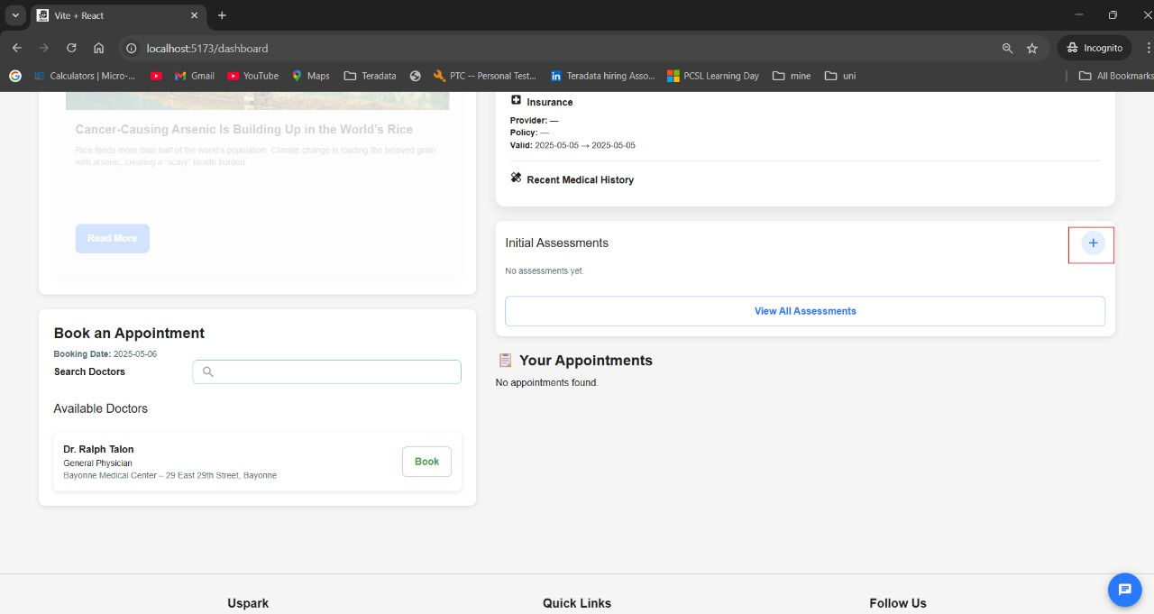

After onboarding process is done, you can take initial assessment by clicking on the ‘+’ icon. This opens the chatbot so that you can chat to take the assessment.

CHATBOT:

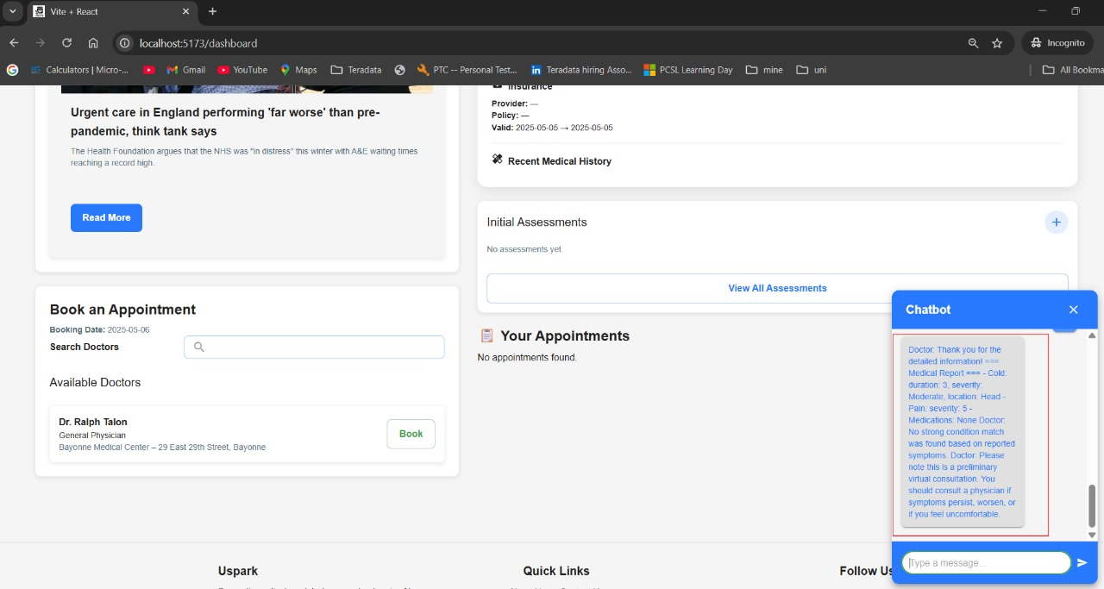

You can chat with the chatbot, which looks like the above image.

END CONVERSATION:

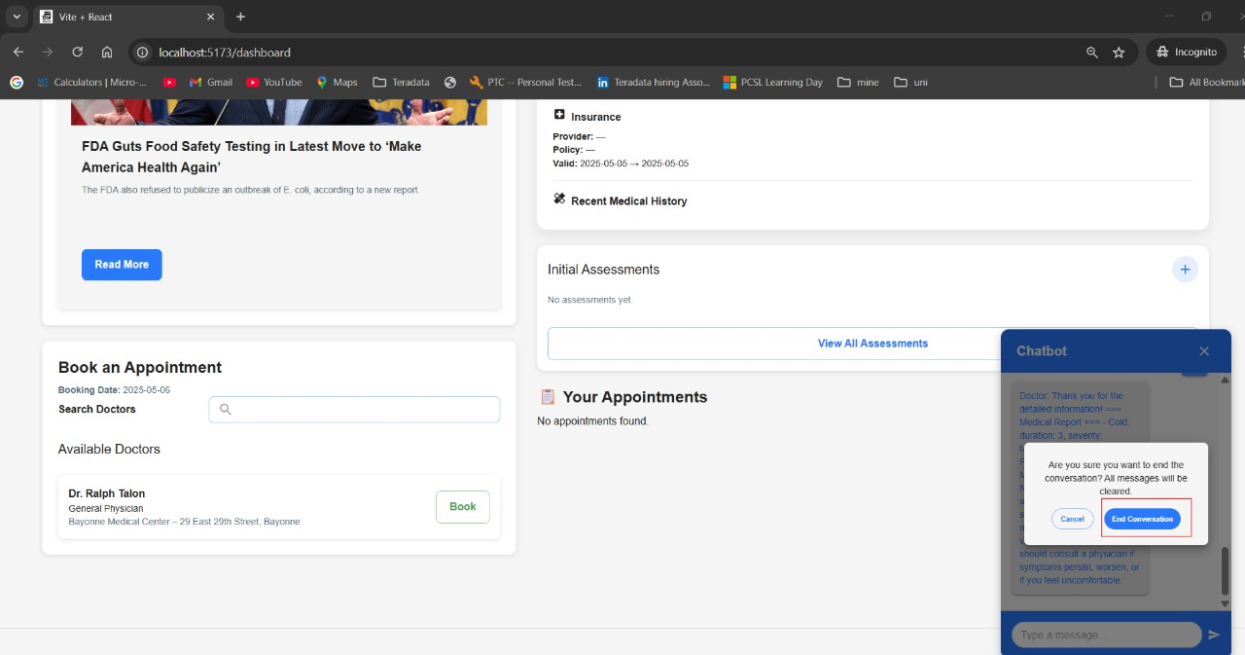

End the conversation by choosing the end conservation button.

MAKING APPOINTMENT:

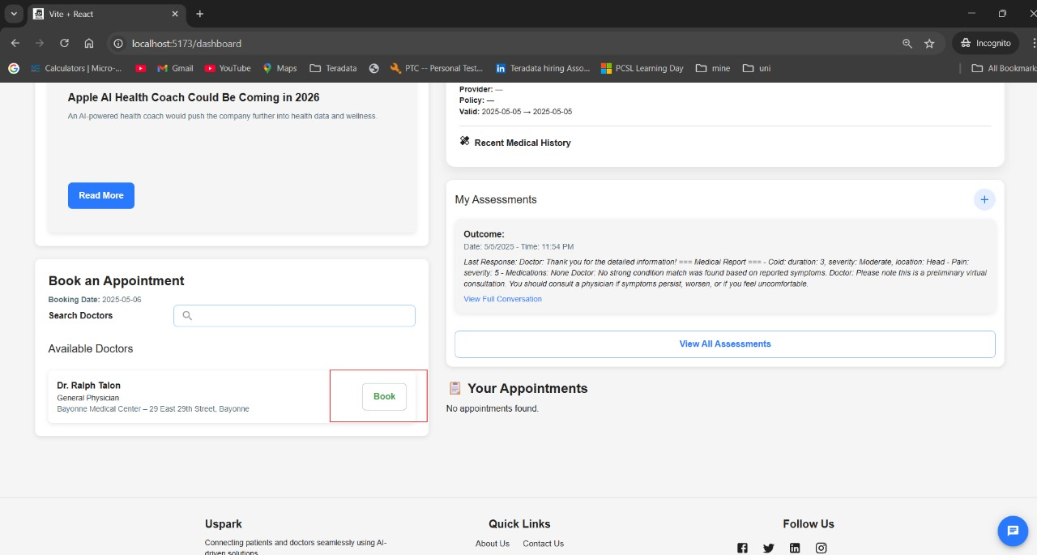

You can book the appointment by clicking on the book button on the left side of the screen, that takes to the appointment booking interface.

BOOKING INTERFACE:

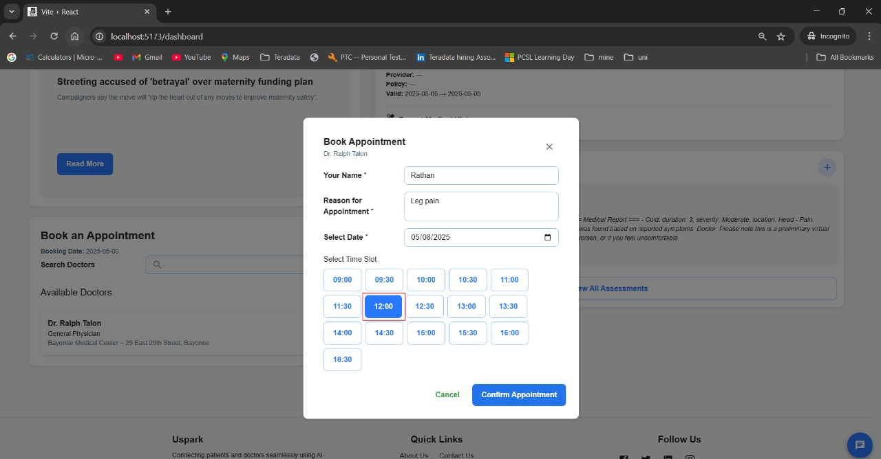

When the appointment book interface opens, the available time slots can be seen and booking can be made by selecting the time slot.

CONFIRM APPOINTMENT:

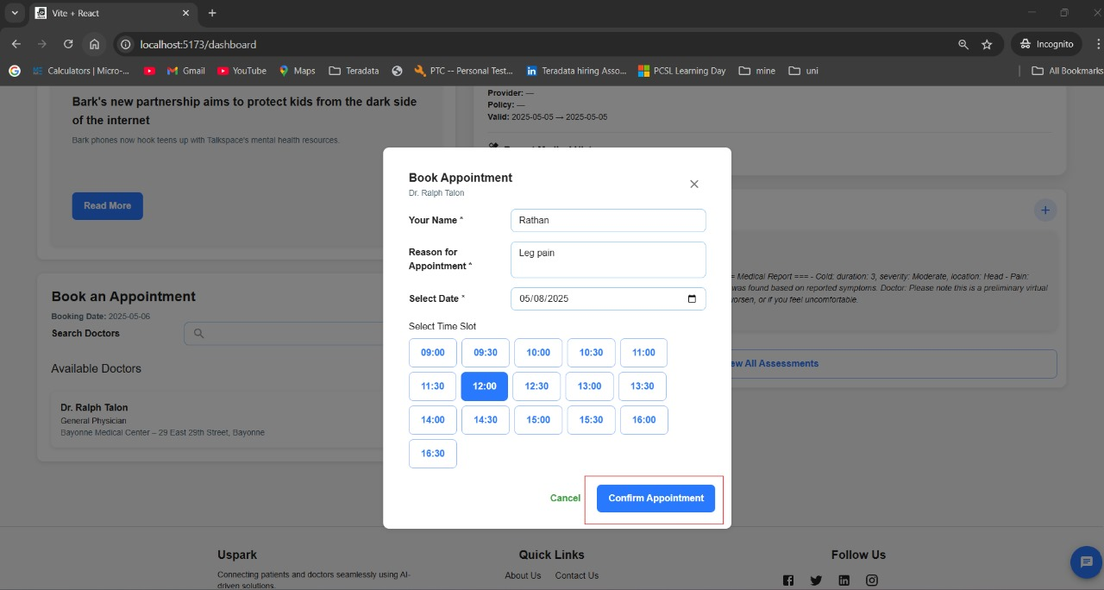

Confirm the appointment by clicking on the confirm appointment button.

After going to the profile, we can update the profile.

UPDATE INSURANCE DETAILS

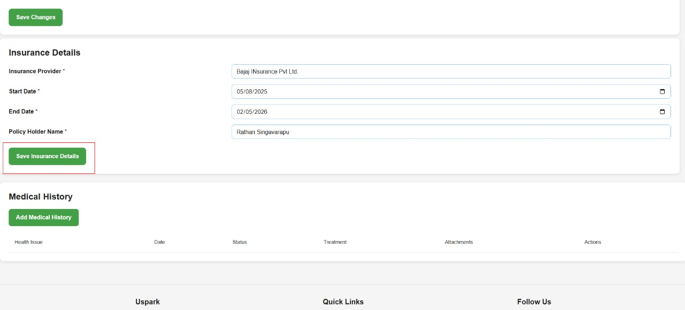

Enter the insurance details, and then click on the save insurance details button to sav insurance details.

ADD MEDICAL HISTORY:

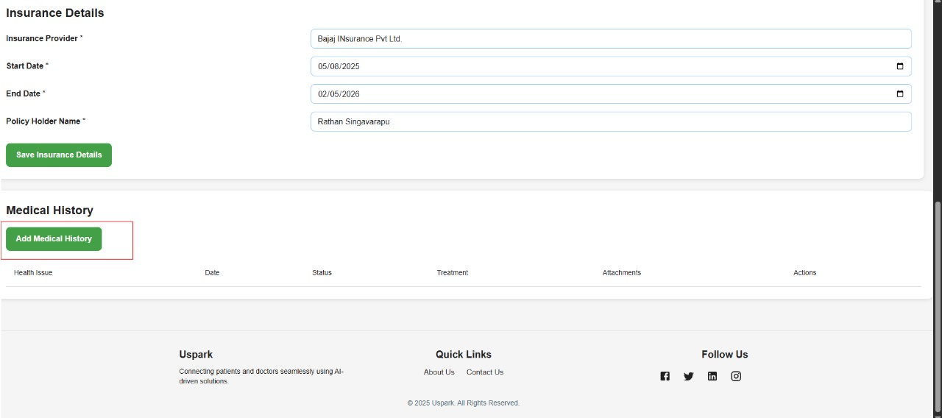

Add the medical history by clicking on add medical history button.

SAVE MEDICAL HISTORY:

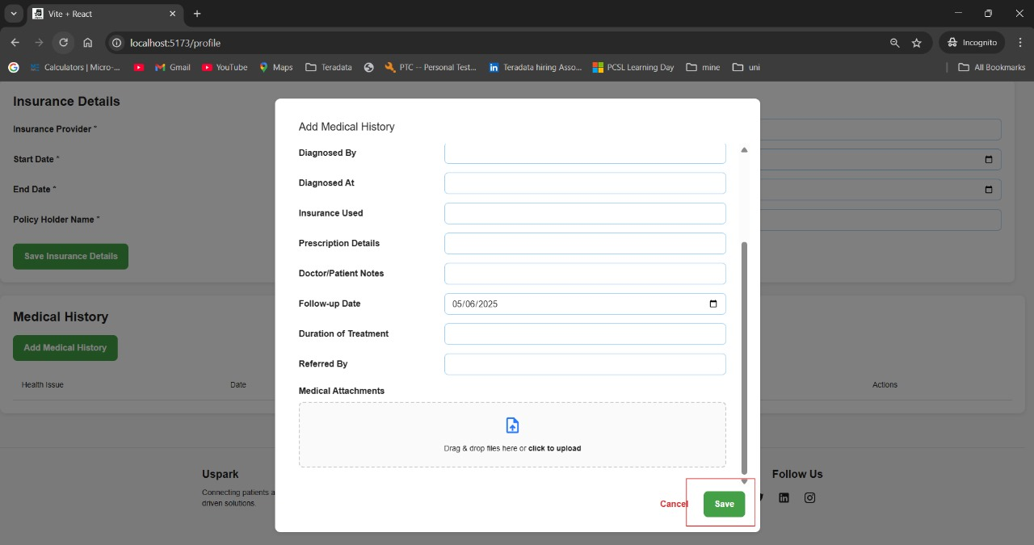

Fill in the needed details and save the details by clicking save button.

VIEW APPOINTMENTS:

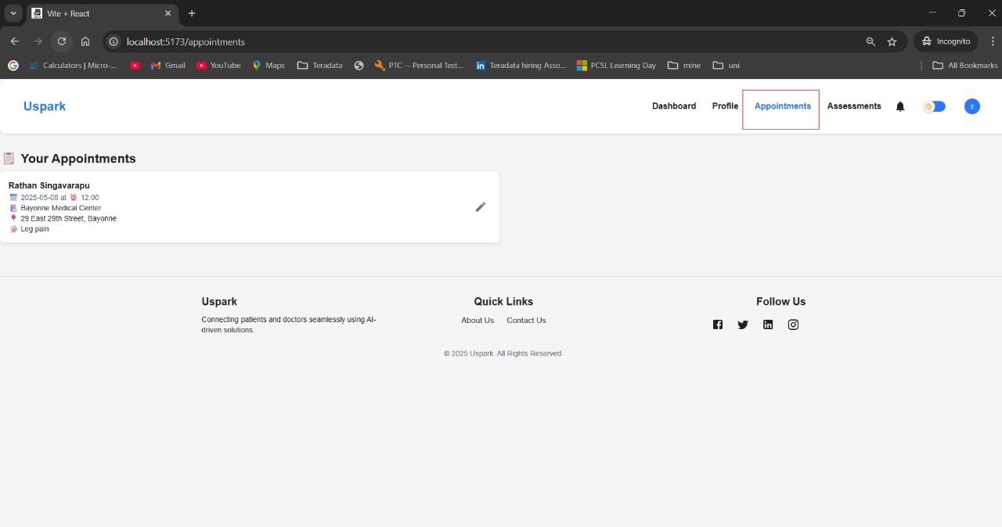

View the appointments of the patient by clicking on appointments button on the header of the patient dashboard.

VIEW ASSESMENTS:

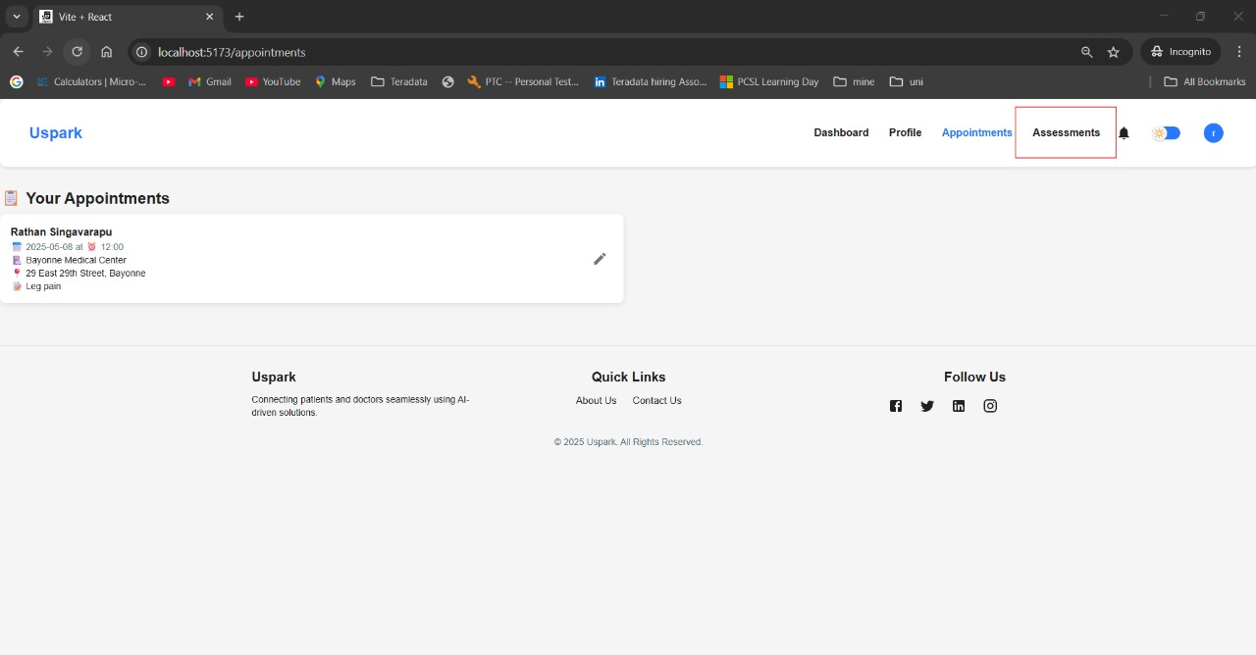

View the assessments of the patient by clicking on assessments button on the header of the patient dashboard